PROJECT REPORT: AN OPERATIONAL AND PREDICTIVE ANALYSIS OF THE BRAZILIAN ECOMMERCE ECOSYSTEM
Prepared by: Daniel Rabi and Jaswinder Brar
Date: June 10, 2026
Target Audience: Olist Senior Leadership Team

1. Executive Summary
Olist operates as a critical marketplace integrator in Brazil’s highly competitive e-commerce landscape, connecting small and medium merchants with major national retail channels. Operating this complex, multi-sided marketplace requires precise operational planning, lean logistical coordination, and proactive inventory management.
This report presents an analytical evaluation of Olist’s transactional ecosystem using historical platform data (olist.sqlite). We focus on two core strategic pillars:
- Exploratory Data Analysis (EDA): Decoding overall trajectories and categorical revenue distributions to expose structural platform vulnerabilities.

- Predictive Modeling Framework: Engineering a robust time-series regression pipeline using tidymodels to forecast next-week category revenue ($t+1$), giving Olist and its partner merchants a distinct logistical advantage, hence improving efficiency and profitability.

2. Reporting Goal 1: Exploratory Data Analysis & Strategic Insights

Finding 1: Olist is Growing Fast, Not Just Having Seasonal Ups and Downs

The Main Point
Olist's weekly sales are rising steadily because the company is growing rapidly, not because of regular seasonal changes like holiday rushes. Also, the big drop in sales at the very end of our data is not a real business crash. It only looks that way because the data file stops recording on July 5, 2018.
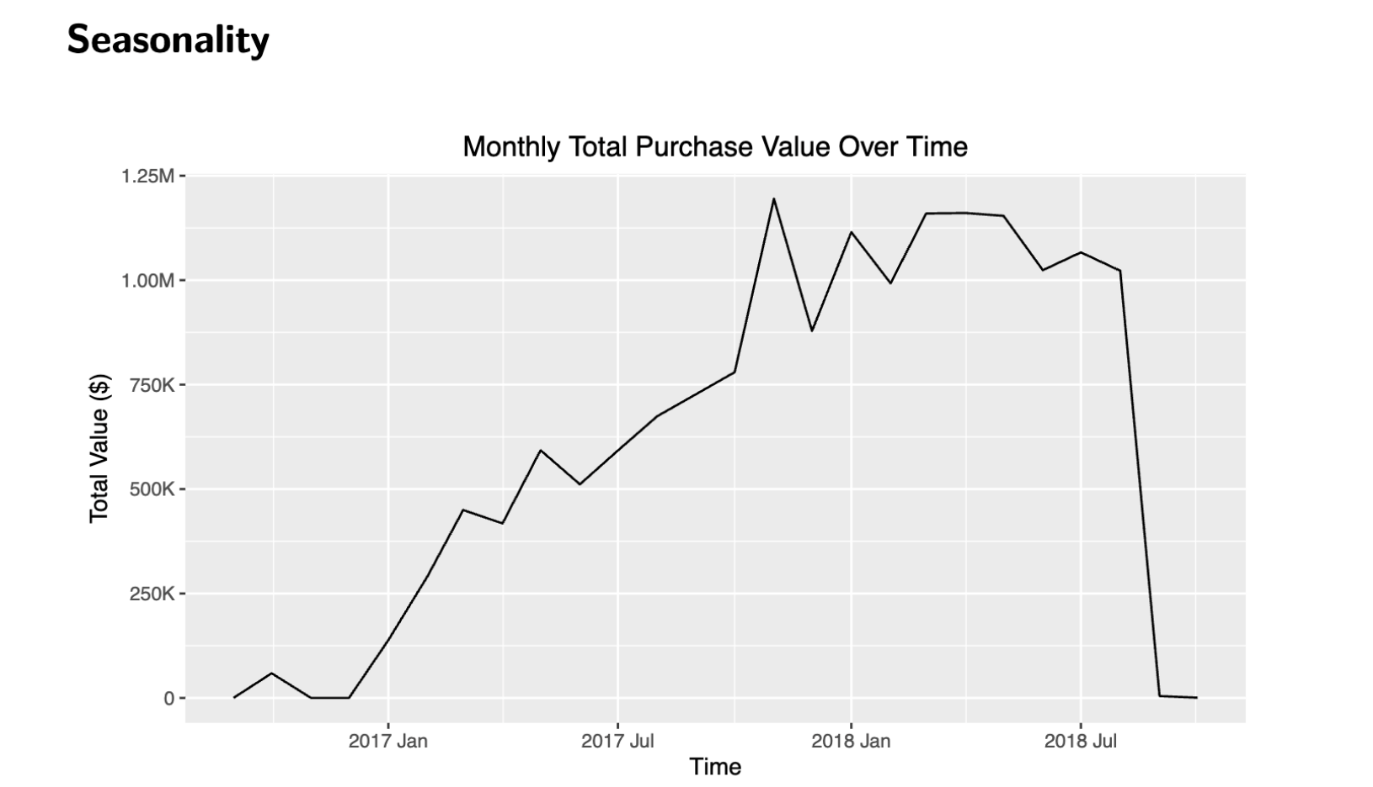
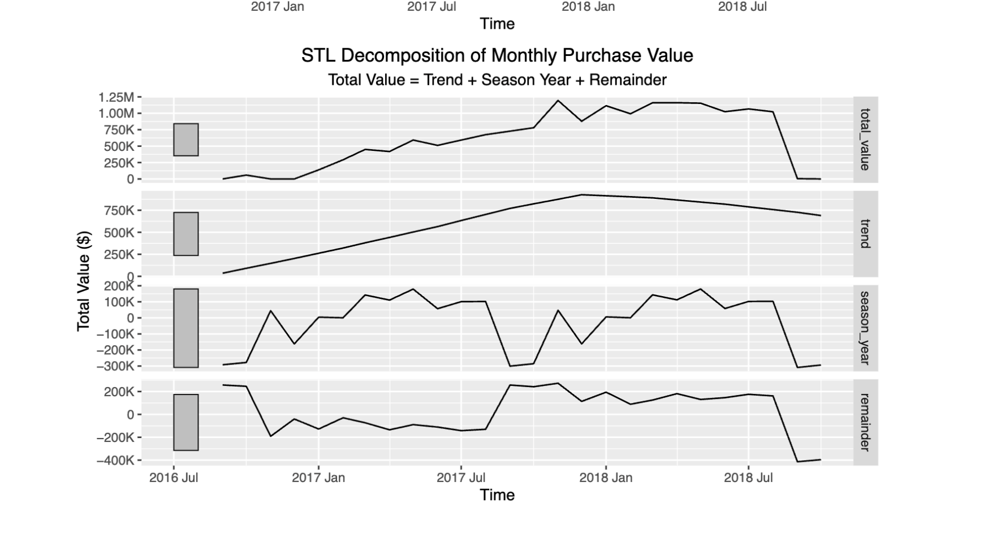

How We Found It
- We organized all the sales data week by week.
- We used a standard statistical tool called STL decomposition to separate the long-term growth trend from short-term noise and yearly patterns.
- The math showed that sales climbed in a steady, almost straight line throughout 2017 and 2018.

Why It Matters for the Business
When a company is growing this fast, it is a mistake to treat every sales dip or jump as a regular seasonal cycle.
Olist should not waste money on short-term seasonal ad campaigns based on the guess that sales will automatically drop at certain times of the year. Instead, management needs to invest that cash into upgrading website servers, helping new sellers sign up, and making payment systems more stable to handle the massive wave of new customers. Seasonal drop will persist, due to the nature of being in a retail business, but management should work making sure that seasonal low’s should be higher than previous seasonal lows.

Finding 2: Most of Olist's Revenue Comes from a Few Key Categories, Creating on time Shipping Risks

The Main Point
A huge portion of Olist's sales comes from just a few expensive, premium lifestyle categories. Health and beauty items, along with watches and gifts, bring in the most money for the platform.

How We Found It
- We combined our product files, order details, and English translations into one master list.
- We added up the total sales for every single category and sorted them from highest to lowest.
- This showed us the top five biggest money-makers:
  - Health and Beauty
  - Watches and Gifts
  - Bed, Bath, and Table
  - Sports and Leisure
  - Computer Accessories

Why It Matters for the Business
The items that make Olist the most money are usually bought for specific, personal reasons like birthdays, holidays, or daily care routines. Because these are expensive, high-quality products, customers have very low patience for shipping mistakes.
If shipping gets delayed for these top categories, customers could leave bad reviews. This stops shoppers from buying from us again and hurts Olist's reputation on the major partner websites where we list our items.
To solve this problem, we can safely rely on our linear prediction model. Because it has a strong 79% R-squared rating, it gives us highly dependable forecasts for next week's sales. This high accuracy allows us to stock our warehouse shelves with the exact amount of inventory needed ahead of time. This ensures that our most important products always ship on time, while also preventing us from wasting valuable warehouse space on low-moving goods.

3. Reporting Goal 2: Predictive Revenue Modeling Engine

3.2 Data Splitting Strategy

To make sure our predictions are realistic, we did not mix or randomize our data. Instead, we split it strictly by time. We used the first 70% of our historical data to train the model and saved the final 30% of the newest data to test it. This accurately mimics a real-world business scenario where you have to use past data to predict the future.

3.3 Feature Engineering and Pipeline Design

We created two different sets of input data to see which operational details would give us the most accurate revenue predictions:
- Feature Set A (The Complete Picture): This set looks at everything. It includes past sales, the number of active sellers on the platform, and delivery performance, such as the percentage of late orders.
- Feature Set B (Sales Only): This set removes all delivery and seller information, focusing purely on past sales numbers.

For both data sets, we calculated 4-week moving averages and weekly fluctuations to track how fast a category's sales were growing or changing. We also normalized all numbers to ensure the mathematical calculations performed smoothly and accurately.

3.4 Model Architectures and Settings

We tested and compared different types of machine learning models, changing their settings to find the best balance between simplicity and accuracy:
- Linear Regression:
- Shallow Decision Tree:
- Deep Decision Tree:
- Small Random Forest:

3.5 Model Evaluation and Comparative Performance
The compiled performance metrics on the independent time-split testing set are structured below.

Model Specification | Input Feature Set | Hyperparameters | Test Root Mean Squared Error (RMSE) | Test Coefficient of Determination (R2)
Linear Regression | Set A (Comprehensive) | Default
Shallow Decision Tree | Set A (Comprehensive) | tree_depth =
Deep Decision Tree | Set B (Minimalist) | tree_depth =
Small Random Forest | Set A (Comprehensive) | trees =

Selection and Technical Justification

3.6 Business Implications of the Chosen Model

Putting this prediction model to work gives Olist strong financial and strategic advantages in two main ways:
- Better Shipping Planning: By knowing next week's sales in advance, Olist can share this information early with delivery partners. If the model predicts a sudden rush of expensive orders in a specific area, we can ensure delivery trucks and resources are ready ahead of time. This prevents shipping delays and protects our high customer review scores.

- Early Warnings for Sellers: We can display these sales forecasts directly on our merchants' account dashboards. If a certain category is expected to see a big spike in orders, the system will prompt those sellers to stock up on extra items before they completely run out. This keeps customers satisfied and protects Olist's sales, and help build trust with the Sellers as well as buyers.

4. Data Challenges and How We Fixed Them
The biggest technical problem in this project was missing and uneven data. While popular categories like health and beauty had steady sales every week, smaller niche categories often had weeks with zero sales or missing customer review scores.
Simply deleting these incomplete weeks would create a huge bias, making our model inaccurate for smaller categories.
To fix this, we created a smart system to fill in the blanks:
- Missing Reviews: If a week was missing a review score, we replaced it with that specific category's long-term average score.
- No Deliveries: If a category had no deliveries in a week, we set its late delivery rate to 0 instead of leaving it blank.
This kept our data timeline smooth and continuous, allowing our machine learning models to run successfully without crashing or making biased predictions.

5. New Data Needed to Improve Accuracy
To make our revenue predictions even more accurate, we recommend adding three external data sources that are not currently in our database:
- Website Traffic and Customer Clicks: Tracking what customers search for, view, or leave in their shopping carts would show us what people want to buy before they make a purchase.

- Marketing and Ad Spend: Tracking how much money is spent on ads and promotions would explain sudden, artificial jumps in sales caused by marketing campaigns.

- Local Weather Reports: Bad weather like heavy rain and flooding causes major shipping delays in Brazil. Adding local weather data would help us predict delivery issues much more accurately, also predict the weather specific iterms like snow shovels, umbrella, beach towels etc.

6. Appendix: Analytical Source Code

